**Creating Microservices for account and loan**

**Codes:**

**Account Microservice**

**AccountController.java:**

**package** com.cognizant.account.controller;

**import** org.springframework.web.bind.annotation.*;

@RestController

@RequestMapping("/accounts")

**public** **class** AccountController {

@GetMapping("/{number}")

**public** Account getAccountDetails(@PathVariable String number) {

**return** **new** Account(number,"savings",234343);

}

**static** **class** Account {

**public** String number;

**public** String type;

**public** **double** balance;

**public** Account(String number,String type,**double** balance) {

**this**.number=number;

**this**.type=type;

**this**.balance=balance;

}

}

}

**AccountApplication.java:**

package com.cognizant.account;

import org.springframework.boot.SpringApplication;

import org.springframework.boot.autoconfigure.SpringBootApplication;

@SpringBootApplication

public class AccountApplication {

public static void main(String[] args) {

SpringApplication.run(AccountApplication.class, args);

}

}

**pom.xml:**

<?xml version="1.0" encoding="UTF-8"?>

<project xmlns="http://maven.apache.org/POM/4.0.0" xmlns:xsi="http://www.w3.org/2001/XMLSchema-instance"

xsi:schemaLocation="http://maven.apache.org/POM/4.0.0 https://maven.apache.org/xsd/maven-4.0.0.xsd">

<modelVersion>4.0.0</modelVersion>

<parent>

<groupId>org.springframework.boot</groupId>

<artifactId>spring-boot-starter-parent</artifactId>

<version>2.7.18</version>

<relativePath/> <!-- lookup parent from repository -->

</parent>

<groupId>com.cognizant</groupId>

<artifactId>account</artifactId>

<version>0.0.1-SNAPSHOT</version>

<name>account</name>

<description>Demo project for Spring Boot</description>

<url/>

<licenses>

<license/>

</licenses>

<developers>

<developer/>

</developers>

<scm>

<connection/>

<developerConnection/>

<tag/>

<url/>

</scm>

<properties>

<java.version>1.8</java.version>

</properties>

<dependencies>

<dependency>

<groupId>org.springframework.boot</groupId>

<artifactId>spring-boot-starter-web</artifactId>

</dependency>

<dependency>

<groupId>org.springframework.boot</groupId>

<artifactId>spring-boot-devtools</artifactId>

<scope>runtime</scope>

<optional>true</optional>

</dependency>

<dependency>

<groupId>org.springframework.boot</groupId>

<artifactId>spring-boot-starter-test</artifactId>

<scope>test</scope>

</dependency>

</dependencies>

<build>

<plugins>

<plugin>

<groupId>org.springframework.boot</groupId>

<artifactId>spring-boot-maven-plugin</artifactId>

</plugin>

</plugins>

</build>

</project>

**Output:**

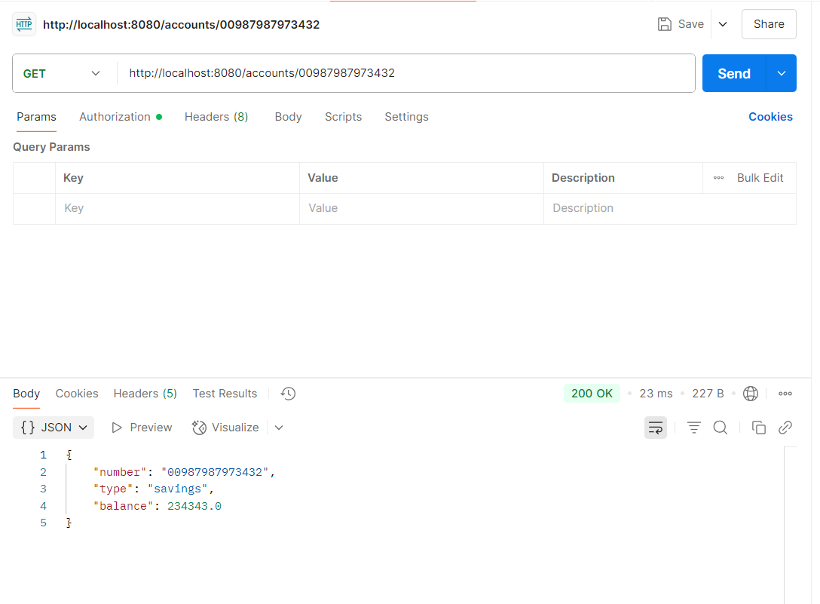

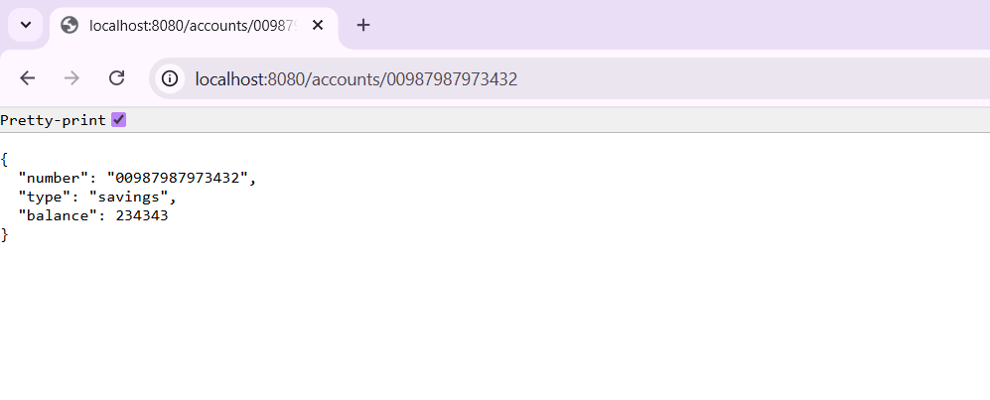

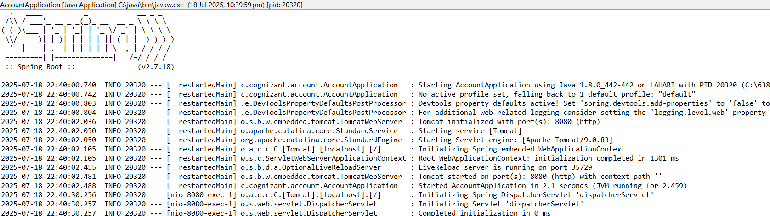

**Loan Microservice**

**LoanController.java:**

**package** com.cognizant.loan.controller;

**import** org.springframework.web.bind.annotation.*;

@RestController

@RequestMapping("/loans")

**public** **class** LoanController {

@GetMapping("/{number}")

**public** Loan getLoanDetails(@PathVariable String number) {

**return** **new** Loan(number,"car",400000,3258,18);

}

**static** **class** Loan{

**public** String number;

**public** String type;

**public** **double** loan;

**public** **double** emi;

**public** **int** tenure;

**public** Loan(String number,String type,**double** loan,**double** emi,**int** tenure) {

**this**.number=number;

**this**.type=type;

**this**.loan=loan;

**this**.emi=emi;

**this**.tenure=tenure;

}

}

}

**LoanApplication.java:**

package com.cognizant.loan;

import org.springframework.boot.SpringApplication;

import org.springframework.boot.autoconfigure.SpringBootApplication;

@SpringBootApplication

public class LoanApplication {

public static void main(String[] args) {

SpringApplication.run(LoanApplication.class, args);

}

}

**pom.xml:**

<?xml version="1.0" encoding="UTF-8"?>

<project xmlns="http://maven.apache.org/POM/4.0.0" xmlns:xsi="http://www.w3.org/2001/XMLSchema-instance"

xsi:schemaLocation="http://maven.apache.org/POM/4.0.0 https://maven.apache.org/xsd/maven-4.0.0.xsd">

<modelVersion>4.0.0</modelVersion>

<parent>

<groupId>org.springframework.boot</groupId>

<artifactId>spring-boot-starter-parent</artifactId>

<version>2.7.18</version>

<relativePath/> <!-- lookup parent from repository -->

</parent>

<groupId>com.cognizant</groupId>

<artifactId>loan</artifactId>

<version>0.0.1-SNAPSHOT</version>

<name>loan</name>

<description>Demo project for Spring Boot</description>

<url/>

<licenses>

<license/>

</licenses>

<developers>

<developer/>

</developers>

<scm>

<connection/>

<developerConnection/>

<tag/>

<url/>

</scm>

<properties>

<java.version>1.8</java.version>

</properties>

<dependencies>

<dependency>

<groupId>org.springframework.boot</groupId>

<artifactId>spring-boot-starter-web</artifactId>

</dependency>

<dependency>

<groupId>org.springframework.boot</groupId>

<artifactId>spring-boot-devtools</artifactId>

<scope>runtime</scope>

<optional>true</optional>

</dependency>

<dependency>

<groupId>org.springframework.boot</groupId>

<artifactId>spring-boot-starter-test</artifactId>

<scope>test</scope>

</dependency>

</dependencies>

<build>

<plugins>

<plugin>

<groupId>org.springframework.boot</groupId>

<artifactId>spring-boot-maven-plugin</artifactId>

</plugin>

</plugins>

</build>

</project>

**Output:**

